SUBTRACTION PROBLEMS
KS1 – 2001 Paper
1.
350 (milliliters)

KS1 – 2002 Paper
2.
KS1 – 2003 Paper 1
3.
KS1 – 2003 Paper 2
4.
KS1 – 2004 Paper 1
5.
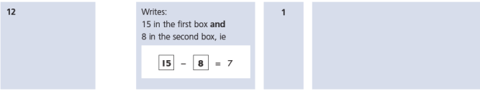
6.
KS1 – 2004 Paper 2
7.
KS1 – 2005 Paper 1
8.
14-5=9
14-9=5

KS1 – 2005 Paper 2
9.
58

10.
136

KS1 – 2007 Paper 2
11.
KS1 – 2009 Paper 1
12.
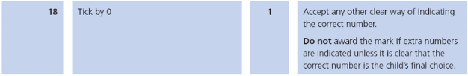
KS1 – 2009 Paper 2
13.
14.
15.
KS1 – 2016 Paper - Arithmetic (Second)
16.
KS1 – 2016 Paper – Reasoning (Second)
17.
KS1 – 2016 Paper – Reasoning (Second)
18.
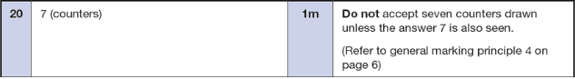
19.
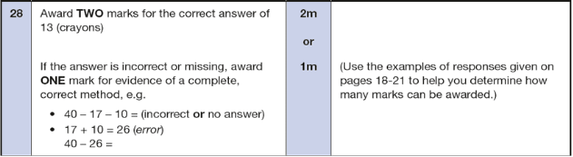
20.
KS1 – 2017 Paper – Reasoning
21.
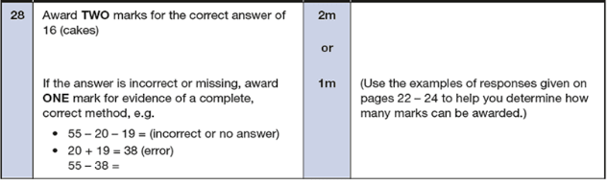
22.
KS1 – 2018 Paper – Reasoning
23.
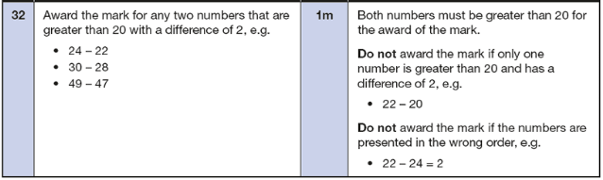
KS1 – 2019 Paper – Reasoning
24.
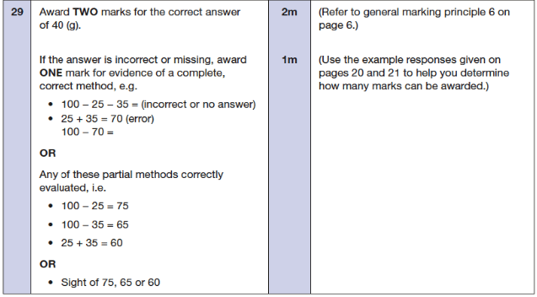
25.
KS1 – 2022 Paper – Reasoning
26.
